Week1 In-Class Exercises
Joshua Franke

First_program:

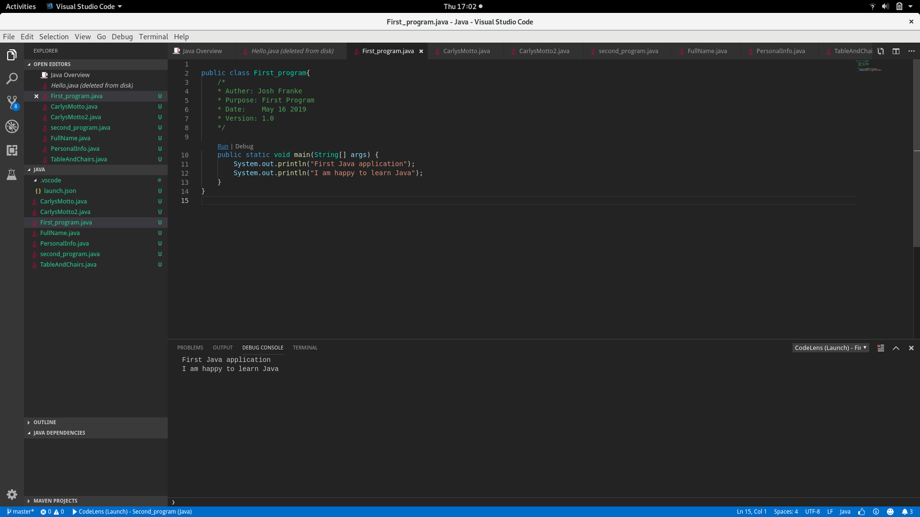
Second_program:
